

**Egyptian Pendant Carving Instructions**

**Egyptians and Soapstone**

Egyptians are known to be one of the first civilisations to have worked on soapstone! They have exemplary carvings done in temples, walls, sarcophagi and among them relief work, inlayed with lapis lazuli or painted with gold. Egyptians also developed symbols to have a written language called Hieroglyphics. They believed jewellery to have spiritual meaning for royalty.

**What is a cartouche?**

A cartouche is an Egyptian hieroglyphic name plate shaped like an oval with a horizontal bar at the base of the oval and a king’s name written inside of the oval. At times amulets were placed in tombs. It was worn often either over or under clothing for protection against evil spirits, or for good health.

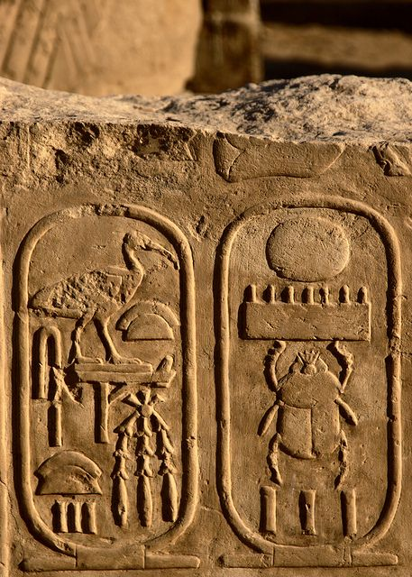 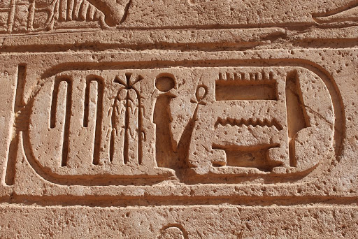 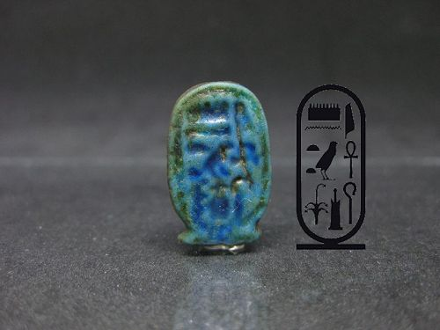

**Carving your Egyptian Cartouche**

**Step 1. Rounding the edges.**

Carefully round all sides, and at the tip where the hole is located. Round the corners and make them oval.

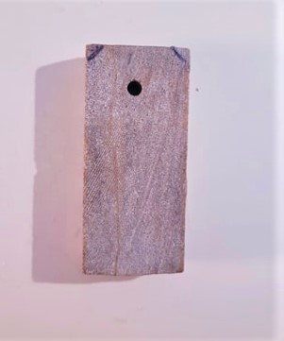 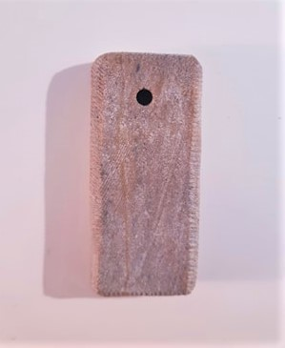

**Step 2. Carve a groove at the bottom.**

Place the file at the bottom of the pendant. Use the file’s width to measure and draw a line with pencil on top of it. Using the edge of your file carve a groove on all sides of the pendant using your measurement as a guideline.

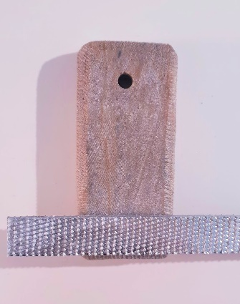 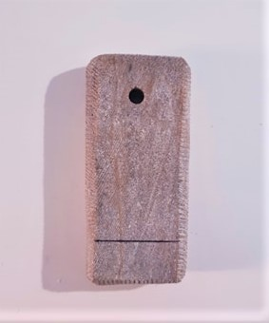 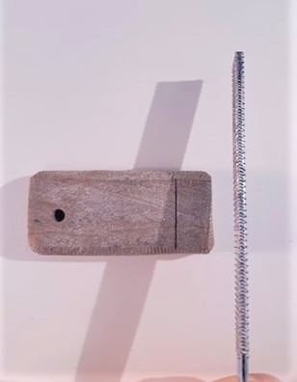 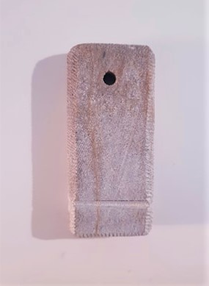

**Step 3. Carve a V shape on both sides of your pendant.**

Use the right and left side of your file to carve a “V” shaped notch on both narrow sides of your pendant. Angle the file as you carve to creak each side of the “V” shaped notch.

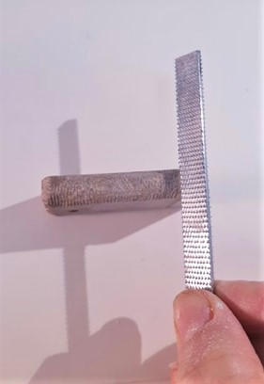 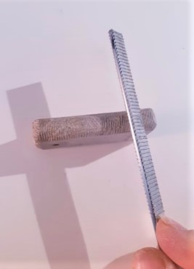 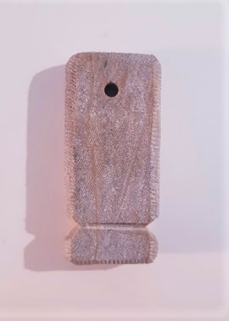

**Step 4. Engrave an oval inside the pendant**

Draw an inner oval at the top part of the pendant with a pencil. Using the corner of your file or another sharp object (sharpened pencil, used old pen etc.) engrave your drawing deep into the stone.

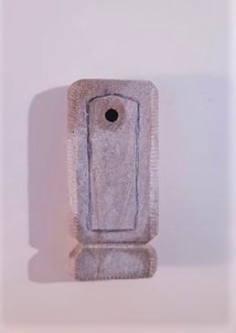 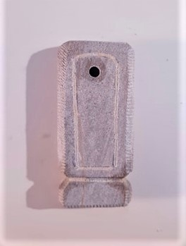

**Step 5 Sand the pendant.**

Dip your red sandpaper (150 grit) in water often and use to sand the pendant well everywhere. After removing all of the big scratches with the red sandpaper sand with the yellow one (400 grit) once again until the pendant feels very smooth to the touch.

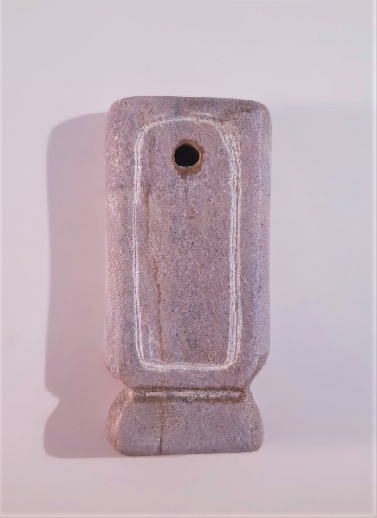

**Step 6 Engrave in hieroglyphics**

Using the Egyptian hieroglyphics find out what are the letters of your name for instance. Practice drawing them on a piece of paper. Engrave your name or initials inside the oval of your pendant placing them one on top of the other in a column.

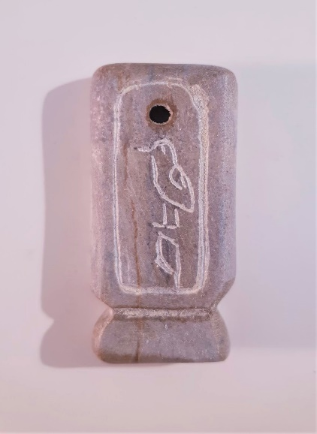 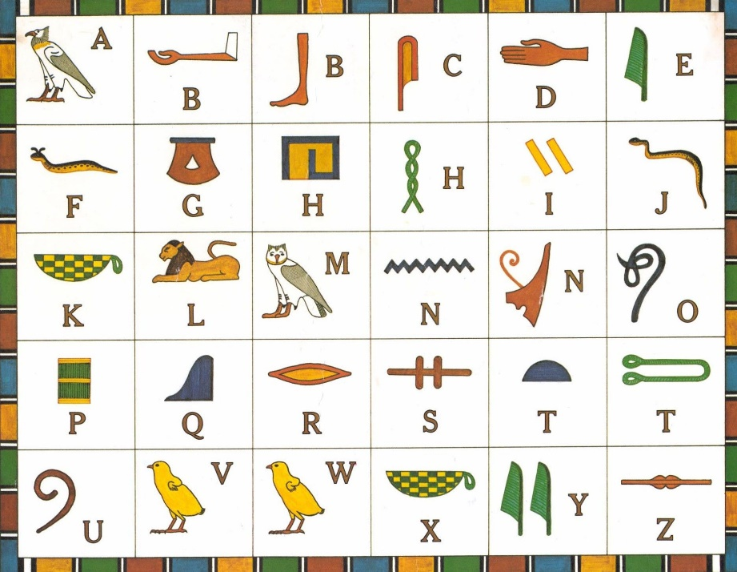

**Step 7 Wax your pendant**

Apply some coconut oil on your pendant and rub well until fully absorbed. Cation: the color of your stone might fade away slightly after some time. When this happens reapply the oil (mineral or cooking oil except olive oil) to bring back the effect of the bright color. Wait two minutes and buff the pendant with your white cloth.

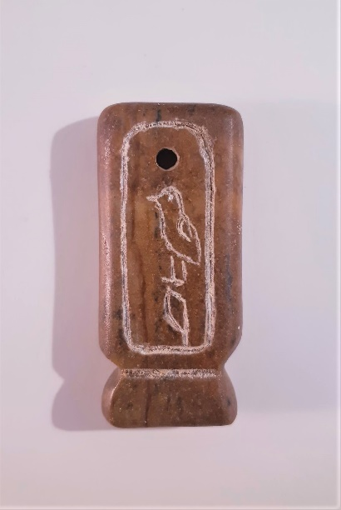

**Step 8 Tie the string**

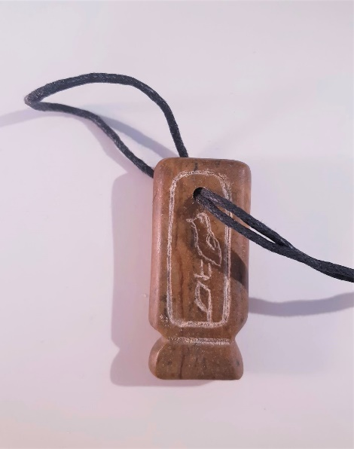 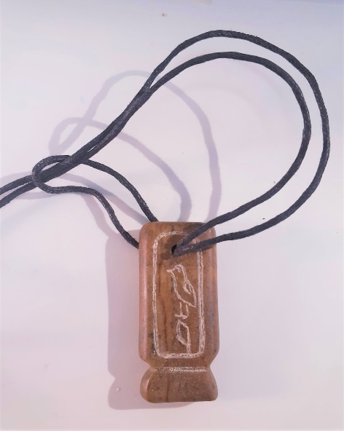 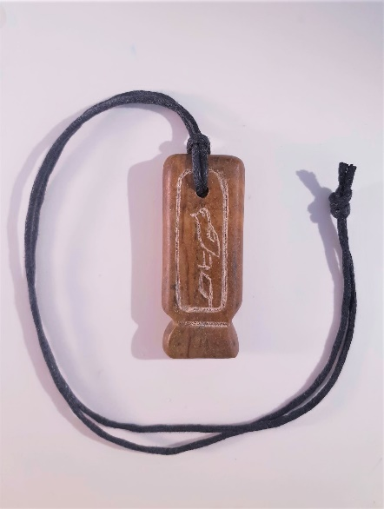

***Enjoy wearing your very own Egyptian Cartouche Pendant!***